28-08-2024
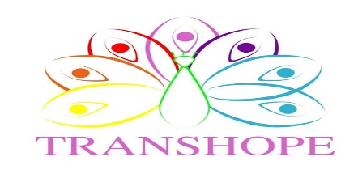
The 9th Annual KZN Mental Health Advocacy Walk and Wellness Fair.

TransHope is announcing the Walk and Wellness Fair planned to happen on Sunday 6th of October 2024. Location of this event will be at Durban Amphitheatre, the time for this Walk and Wellness Fair will begin at 08:00am – 12:00pm.
KwaZulu-Natal Mental Health Advocacy Group aims to raise public and political awareness about mental health to create a culture of collaboration amongst diverse stakeholders in mental health. The event acknowledges the challenges we as Africans face that lead to mental health disorders and wants to show support by advocating towards a healthy lifestyle. As there are many mental health problems such as childhood abuse; trauma; poverty; and social isolation; etc, the campaign is to teach the public on how to manage mental health risks and causes and how to prevent mental health issues.
TransHope is filled with joy to be invited to participate on the success of the event as we are an advocacy for trans and gender diverse community. We seek to promote the importance of mental health to trans and gender individuals along with their families to create a safe healthy space. There will be an activity line up of which involves physical and mental fitness that every individual is welcome to participate on to improve their social well-being and mental well-being.
Please join the awareness campaign and participate to show support to the public and society in order to improve ones mental well-being. Entry is free for all. Register here: https://forms.gle/si37MXeJ7x9hd33Y6

Please contact : Ms Sazi Jali
Job Title : Executive Director
Company name : TransHope
Contact no. : 065 826 0386

